**Computer Organization:**

*Class Assignment 1*

Question Statement: Write a C program to divide two numbers.

Code:

*// Program for division of two numbers*

*#include* <stdio.h>

int main()

{

    double a, b;

    printf("Enter Number 1 :\n");

    scanf("%lf", &a);

    printf("Enter Number 2 :\n");

    scanf("%lf", &b);

*if* (b != 0)

    {

        double ans = (a / b);

        printf("a/b = %lf", ans);

    }

*else*

    {

        printf("Divide by Zero Error!");

    }

*return* 0;

}

Sample Test Cases:

1.) [100, 25] (Perfectly Divisible Integer Pair)

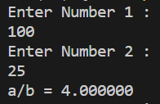

2.) [23, 12] (Not-Completely Divisible Integer Pair)

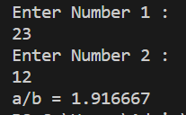

3.) [20, 0] (Divide by Zero Error)

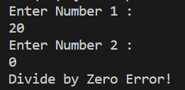

4.) [2.50, 1.25] (Perfectly Divisible Decimal Pair)

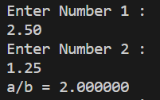

5.) [27.12, 13.25] (Not-Completely Divisible Decimal Pair)

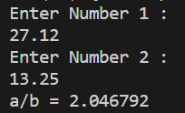

Submitted By:

Roll Number: U19CS012 (D-12)

Name: Bhagya Rana